Year 8 homework – SUM 2 electricity /Potential difference
Use BBC bitesize to help you: Electric current and potential difference guide for KS3 physics students - BBC Bitesize
- What is the voltage across each bulb? The bulbs are identical and the battery provides 6V . One circuit is series & the other is parallel.
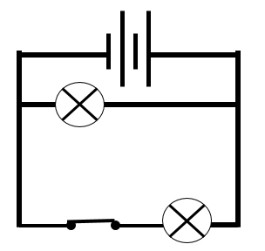
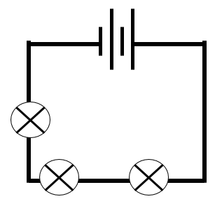

- What happens to potential difference in a parallel circuit? | - What happens to potential difference in a series circuit?
- How can you increase the potential difference in an electrical circuit – hint think about the battery/cell or the number of bulbs?

